LABSHEET 05
Name- HARSHI JAIN, cuid- cu240250174, roll no- 21
TASK 5.1 React Login Page

import React, { useState } from 'react';
/**
- Task 5.1 — React Login Form
- Controlled inputs + regex-based email/password validation * with interactive error badges rendered on invalid patterns. */

// Regex security patterns const EMAIL_PATTERN = /^[a-zA-Z0-9._%+-]+@[a-zA-Z0-9.-]+\.[a-zA-Z]{2,}$/; const PASSWORD_PATTERN =
/^(?=.*[a-z])(?=.*[A-Z])(?=.*\d)(?=.*[@$!%*?&#^()_\-+=]).{8,}$/;

function validateEmail(value) {
if (!value) return 'Email is required.';
if (!EMAIL_PATTERN.test(value)) return 'Enter a valid email address (e.g. name@domain.com).'; return '';
}

function validatePassword(value) {
if (!value) return 'Password is required.';
if (value.length < 8) return 'Password must be at least 8 characters.'; if (!PASSWORD_PATTERN.test(value))
return 'Must include uppercase, lowercase, number & special character.'; return '';
}

export default function LoginForm() {
const [formData, setFormData] = useState({ email: '', password: '' }); const [errors, setErrors] = useState({ email: '', password: '' }); const [touched, setTouched] = useState({ email: false, password: false }); const [submitted, setSubmitted] = useState(false);

const handleChange = (e) => { const { name, value } = e.target;
setFormData((prev) => ({ ...prev, [name]: value }));

// Live regex validation as the user types const errorMsg = name === 'email' ? validateEmail(value) : validatePassword(value); setErrors((prev) => ({ ...prev, [name]: errorMsg })); };

const handleBlur = (e) => { const { name } = e.target; setTouched((prev) => ({ ...prev, [name]: true }));
};
const handleSubmit = (e) => { e.preventDefault(); const emailError = validateEmail(formData.email); const passwordError = validatePassword(formData.password); setErrors({ email: emailError, password: passwordError }); setTouched({ email: true, password: true });

if (!emailError && !passwordError) { setSubmitted(true);
}

};

const isValid = !errors.email && !errors.password && formData.email && formData.password;

return (
<div className="card">
<h2 className="card-title">Sign in to your account</h2>
<p className="card-subtitle">Task 5.1 — Controlled Login Form with Regex Validation</p>

<form onSubmit={handleSubmit} noValidate>
<div className="field-group">
<label className="field-label" htmlFor="email">Email address</label>
<input id="email" name="email" type="text"
className={`field-input ${ touched.email ? (errors.email ? 'invalid' : 'valid') : ''
}`}
placeholder="you@example.com" value={formData.email} onChange={handleChange} onBlur={handleBlur}
/>
{touched.email && errors.email && (
<div className="error-badge">⚠ {errors.email}</div>
)}
{touched.email && !errors.email && (
<div className="success-badge">✓ Looks good</div>
)}
</div>

<div className="field-group">
<label className="field-label" htmlFor="password">Password</label>
<input id="password" name="password" type="password"
className={`field-input ${ touched.password ? (errors.password ? 'invalid' : 'valid') : ''
}`} placeholder="Enter password" value={formData.password} onChange={handleChange} onBlur={handleBlur}
/>
{touched.password && errors.password && (
<div className="error-badge">⚠ {errors.password}</div>
)}
{touched.password && !errors.password && (
<div className="success-badge">✓ Strong pattern match</div>
)}
</div>

<button type="submit" className="primary-btn" disabled={submitted}> {submitted ? 'Signed In ✓' : 'Sign In'} </button>

{submitted && (
<p className="footer-note" style={{ color: 'var(--success)' }}> Authentication successful — welcome back!
</p> )}
</form>
</div>
); }
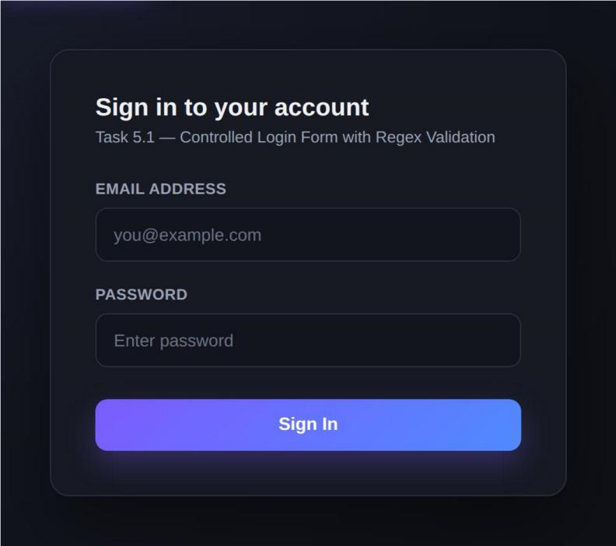
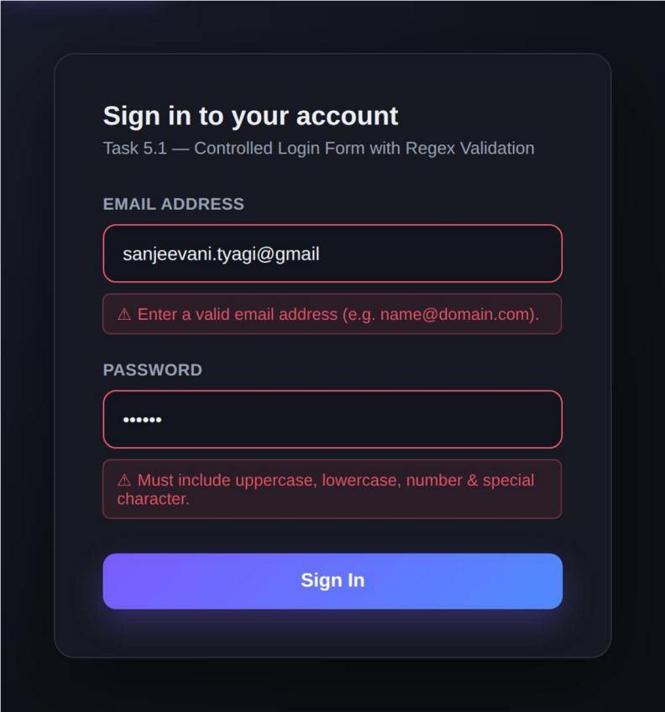
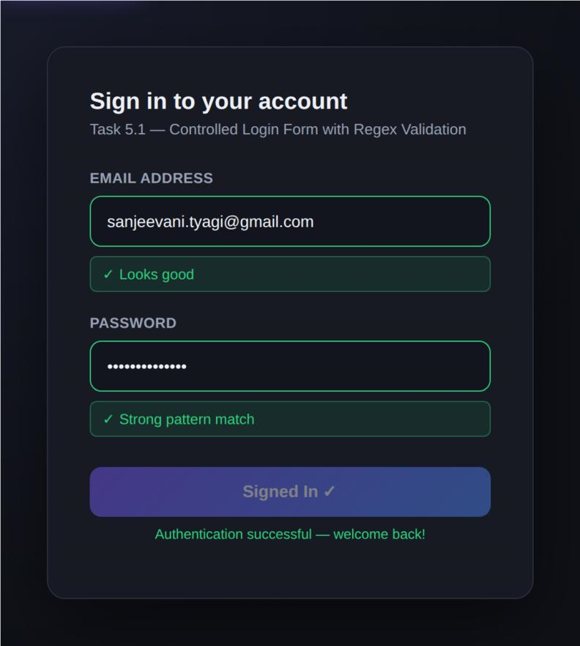

TASK 5.2 Password Strength Checker
import React, { useMemo } from 'react';
/**
- Task 5.2 — Reusable Password Strength Checker sub-component
- Maps text input variations to a dynamic visual progress tracker bar.
- Accepts `password` via props so it can be reused inside ANY parent form. */

const STRENGTH_LEVELS = [
{ label: 'Very Weak', color: '#ff5b6e', width: '20%' },
{ label: 'Weak', color: '#ff8c42', width: '40%' },
{ label: 'Fair', color: '#f5b642', width: '60%' },
{ label: 'Good', color: '#4f8bff', width: '80%' },
{ label: 'Strong', color: '#2ecf7d', width: '100%' }, ];

function scorePassword(password) { if (!password) return 0; let score = 0; const rules = { length: password.length >= 8, lowercase:
/[a-z]/.test(password), uppercase:
/[A-Z]/.test(password), number:
/\d/.test(password),
special: /[@$!%*?&#^()_\-+=]/.test(password), };
Object.values(rules).forEach((met) => met && score++);

// Bonus for longer passwords if (password.length >= 12) score++;
return { score: Math.min(score, 5), rules
};
}

export default function PasswordStrengthChecker({ password, showRules = true }) { const { score, rules } = useMemo(() => { const result = scorePassword(password); return result === 0 ? { score: 0, rules: {} } : result; }, [password]);

const levelIndex = Math.max(score - 1, 0); const level = password ? STRENGTH_LEVELS[levelIndex] : null;

return (
<div className="strength-checker">
<div className="strength-bar-track">
<div
className="strength-bar-fill" style={{
width: level ? level.width : '0%', background: level ? level.color : 'transparent',
}}
/>
</div>

<div className="strength-label-row">
<span className="strength-label" style={{ color: level ? level.color : 'var(--text-muted)' }}> {level ? level.label : 'Enter a password'} </span>
<span style={{ color: 'var(--text-muted)' }}>{password ? `${password.length} chars` : ''}</span>
</div>

{showRules && password && (
<div className="strength-rules">
<div className={`strength-rule ${rules.length ? 'met' : ''}`}>
<span className="rule-dot" /> Minimum 8 characters </div>
<div className={`strength-rule ${rules.uppercase ? 'met' : ''}`}> <span className="rule-dot" /> Uppercase letter
</div>
<div className={`strength-rule ${rules.lowercase ? 'met' : ''}`}> <span className="rule-dot" /> Lowercase letter
</div>
<div className={`strength-rule ${rules.number ? 'met' : ''}`}> <span className="rule-dot" /> Number
</div>
<div className={`strength-rule ${rules.special ? 'met' : ''}`}> <span className="rule-dot" /> Special character
</div>
</div>
)}
</div> );
}
import React, { useState } from 'react'; import
PasswordStrengthChecker from './PasswordStrengthChecker.jsx';
/**
* Parent component that owns the password state and passes it down * to the reusable PasswordStrengthChecker via props.
*/
export default function PasswordStrengthDemo() { const [password, setPassword] = useState('');

return (

<div className="card">
<h2 className="card-title">Create a new password</h2>
<p className="card-subtitle">Task 5.2 — Reusable Password Strength Sub-Component</p>

<div className="field-group">
<label className="field-label" htmlFor="new-password">New password</label>
<input id="newpassword" type="password" className="field-input"
placeholder="Type to test strength..." value={password} onChange={(e) => setPassword(e.target.value)}
/>
</div>

{/* Reusable child component — receives password via props */} <PasswordStrengthChecker password={password} showRules />

<button className="primary-btn" style={{ marginTop: 24 }}> Set Password
</button>
</div> );
}
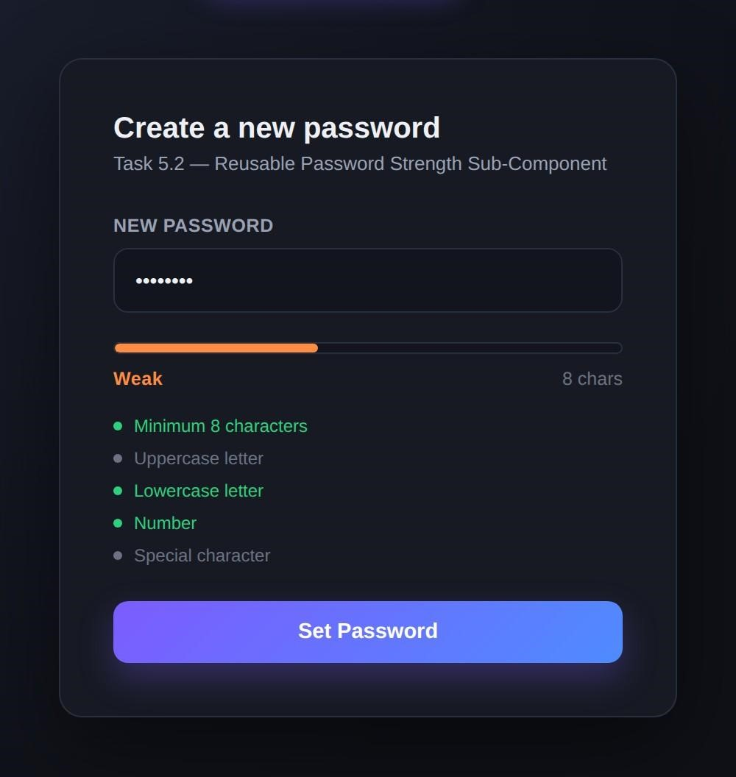
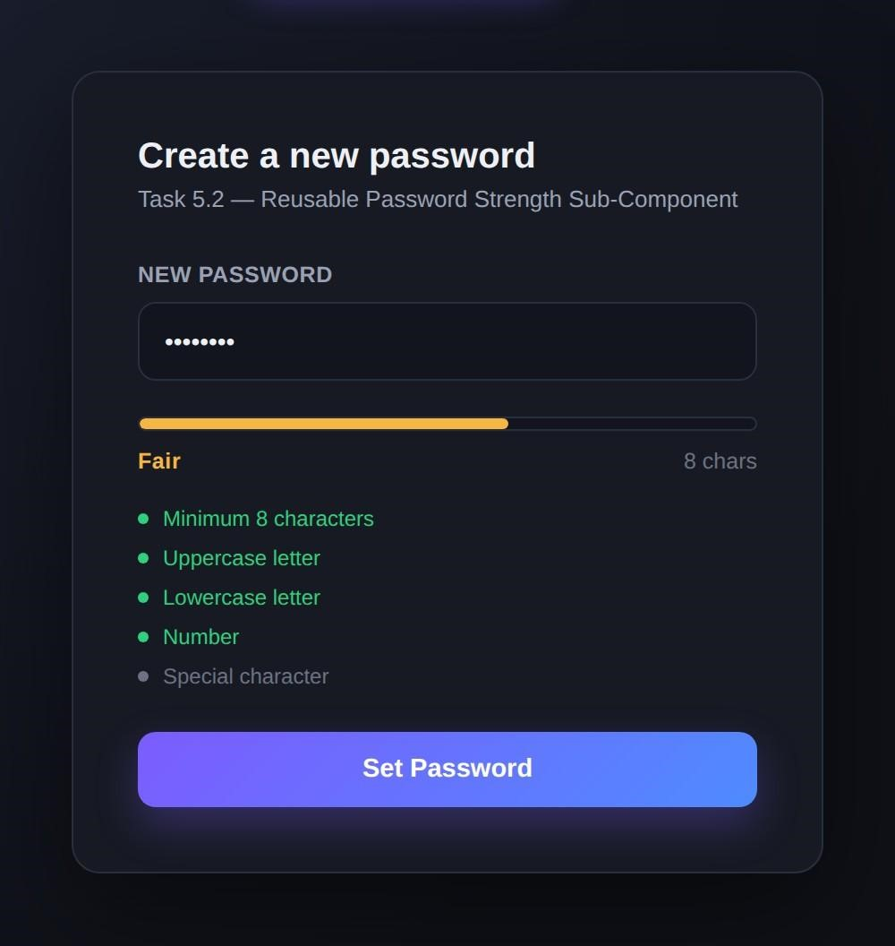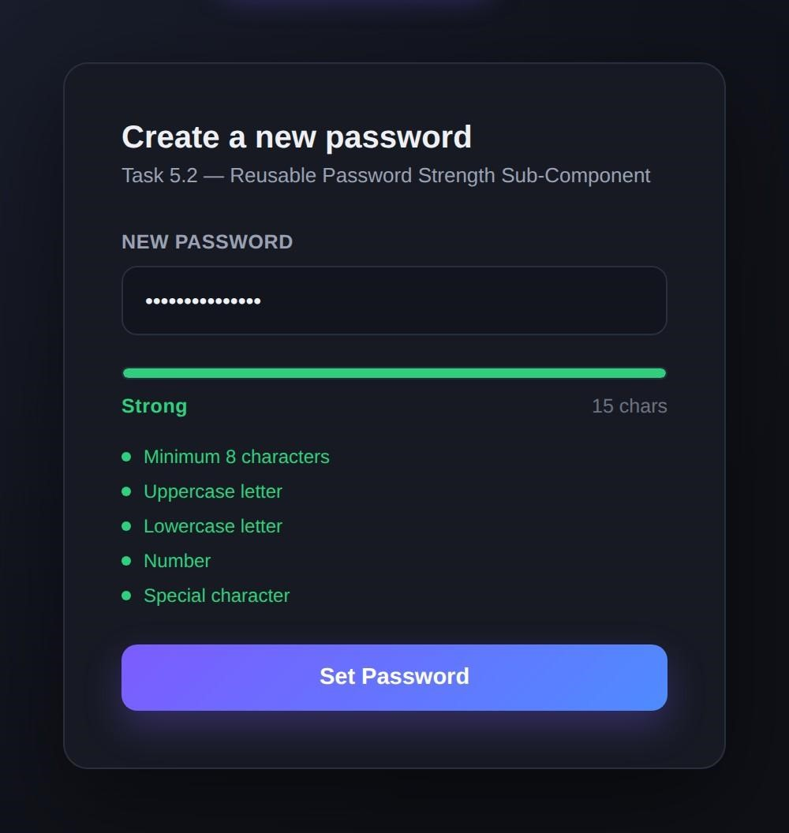

TASK 5.3 Multi-Step Onboarding Form

OnboardingWizard (parent — owns state: formData, step, submitted) |
|-- StepAccount (props: data, onChange) -> Step 1: Account
|-- StepPersonalInfo (props: data, onChange) -> Step 2: Personal Info
|-- StepFinish (props: data, submitted) -> Step 3: Finish / Review |
|-- Stepper indicator (rendered inline, driven by "step")
|-- Back / Next / Submit buttons (call goBack / goNext / handleFinalSubmit)
import React, { useState } from 'react'; import StepAccount from './steps/StepAccount.jsx'; import StepPersonalInfo from './steps/StepPersonalInfo.jsx'; import StepFinish from './steps/StepFinish.jsx';
/**
- Task 5.3 — Multi-Step Onboarding Form Wizard
- Parent owns ALL wizard state via useState and passes data + onChange
- down to each child step (props-based parent-child communication). * Child components never manage their own state — fully controlled. */

const STEP_LABELS = ['Account', 'Personal Info', 'Finish'];

const initialFormState = { username: '', email: '', password: '', fullName: '', course: '', city: '', };

export default function OnboardingWizard() {
const [step, setStep] = useState(0); // 0 = Account, 1 = Personal Info, 2 = Finish const [formData, setFormData] = useState(initialFormState); const [submitted, setSubmitted] = useState(false);

// Passed down as `onChange` — merges partial updates into wizard state const updateFormData = (partial) =>
{
setFormData((prev) => ({ ...prev, ...partial })); };

const goNext = () => setStep((s) => Math.min(s + 1, STEP_LABELS.length - 1)); const goBack = () => setStep((s) => Math.max(s - 1, 0)); const handleFinalSubmit = () => {
// Final submission routine — in a real app this posts formData to an API setSubmitted(true); };

const renderStep = () => { switch (step) { case
0: return <StepAccount data={formData} onChange={updateFormData} />; case 1:
return <StepPersonalInfo data={formData} onChange={updateFormData} />; case 2:
return <StepFinish data={formData} submitted={submitted} />; default:
return null;
} }; return (
<div className="card card-wide">
<h2 className="card-title">Create your account</h2>
<p className="card-subtitle">Task 5.3 — Multi-Step Onboarding Wizard</p>

{/* Step indicator */}
<div className="stepper">
{STEP_LABELS.map((label, i) => (
<React.Fragment key={label}>
<div className="step-dot-wrap">
<div className={`step-dot ${i === step ? 'active' : ''} ${i < step ? 'done' : ''}`}> {i < step ? '✓' : i + 1}
</div>
<span className={`step-label ${i === step ? 'active' : ''}`}>{label}</span>
</div>
{i < STEP_LABELS.length - 1 && (
<div className={`step-connector ${i < step ? 'done' : ''}`} />
)}
</React.Fragment>
))}
</div>

{renderStep()}

{!submitted && (
<div className="btn-row">
{step > 0 && (
<button className="secondary-btn" onClick={goBack}>
Back
</button>
)}
{step < STEP_LABELS.length - 1 && (
<button className="primary-btn" onClick={goNext}>
Next
</button>
)}
{step === STEP_LABELS.length - 1 && (
<button className="primary-btn" onClick={handleFinalSubmit}>
Submit
</button>
)}
</div>
)}
</div> );
}

import React from 'react'; /**
- Step 1 — Account details.
- Purely controlled: receives `data` + `onChange` from the parent wizard, * holds no state of its own.
*/
export default function StepAccount({ data, onChange }) {
const handle = (e) => onChange({ [e.target.name]: e.target.value }); return ( <div>
<div className="field-group">
<label className="field-label" htmlFor="username">Username</label>
<input id="username" name="username" className="field-input" placeholder="e.g. sanjeevani_t" value={data.username} onChange={handle}
/>
</div>
<div className="field-group">
<label className="field-label" htmlFor="onboard-email">Email address</label>
<input id="onboardemail" name="email" className="field-input" placeholder="you@example.com" value={data.email} onChange={handle}
/>
</div>
<div className="field-group">
<label className="field-label" htmlFor="onboard-password">Password</label>
<input id="onboardpassword" name="password" type="password" className="field-input" placeholder="Create a password"
value={data.password} onChange={handle}
/>
</div>
</div> );
}
import React from 'react'; /**
* Step 2 — Personal information. * Also a controlled child: state lives in the parent OnboardingWizard.
*/
export default function StepPersonalInfo({ data, onChange }) { const handle = (e) => onChange({ [e.target.name]: e.target.value }); return
(
<div>
<div className="field-group">
<label className="field-label" htmlFor="fullName">Full name</label>
<input id="fullName" name="fullName" className="fieldinput" placeholder="e.g. Sanjeevani Tyagi" value={data.fullName} onChange={handle}
/>
</div>
<div className="field-group">
<label className="field-label" htmlFor="course">Course / Program</label>
<input id="course" name="course" className="field-input" placeholder="e.g. B.Tech CSE" value={data.course}
onChange={handle}
/>
</div>
<div className="field-group">
<label className="field-label" htmlFor="city">City</label>
<input id="city" name="city" className="field-input" placeholder="e.g. Dehradun" value={data.city} onChange={handle}
/>
</div>
</div> );
}

import React from 'react'; /**
* Step 3 — Review & Finish. * Displays a read-only summary of all state collected across previous steps.
*/
export default function StepFinish({ data, submitted }) { if (submitted) { return (
<div style={{ textAlign: 'center', padding: '12px 0' }}>
<div className="finish-icon">✓</div>
<h3 style={{ margin: '0 0 6px 0' }}>You're all set, {data.fullName.split(' ')[0] || 'there'}!</h3> <p className="card-subtitle" style={{ marginBottom: 0 }}> Your onboarding data has been submitted successfully. </p>
</div>
); } return (
<div>
<p className="card-subtitle" style={{ marginBottom: 16 }}>
Review your details before finishing. </p>
<div className="summary-row"><span>Username</span><span>{data.username || '—'}</span></div>
<div className="summary-row"><span>Email</span><span>{data.email || '—'}</span></div>
<div className="summary-row"><span>Full Name</span><span>{data.fullName || '—'}</span></div>
<div className="summary-row"><span>Course</span><span>{data.course || '—'}</span></div>
<div className="summary-row"><span>City</span><span>{data.city || '—'}</span></div> </div> );
}

